LNWR Renown Class March 2025

By Peter F. Davis G1MRA #257

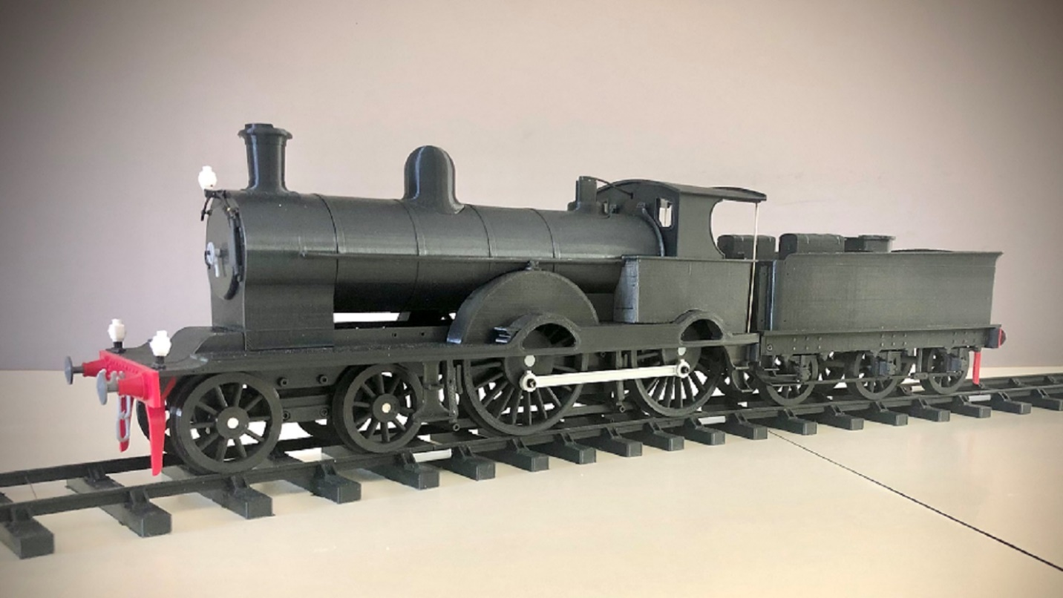

Basically Renown Class to 10mm scale, 3D printed in PLA plus on an Elegoo Neptune 3 Pro printer.

Each drive axle is powered by an N-20 motor via printed gears. These, with the drivers, ride in what I call the motor pan. This is allowed to pivot, adjusting to possible track irregularity. The tender holds the batteries, forward/reverse switch and speed controller. The speed controller is located beneath what would be called the water filler lid. A printed knob connects to the controller’s pot and becomes part of the lid. The F/R switch in front of the coal space. I chose the simple controls, however, radio control could be an option.

The photo as printed. Very little sanding and paint, black on the base of the lamps and gray on the buffer heads.

As of March 2025, I’ve only run on the few yards of tenmille track I have and 5 pieces of printed 10’ radius curves (about 3’). This summer, I hope to visit an outdoor track and have a good run with my milk train. MOO!

**1 Motor Pan**

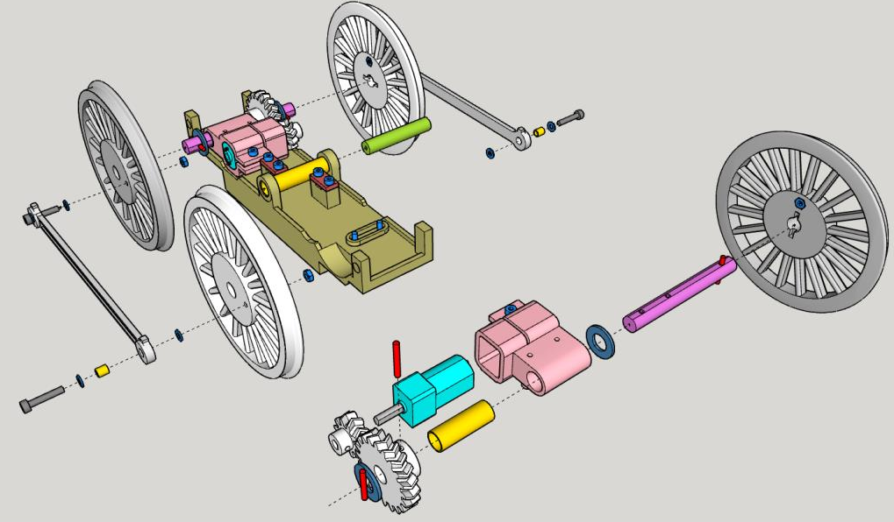

Note; When soldering wires to the motors the wires should lead away toward the wire clamps. The motors have +/\_ marked near the termminals, reverse the polarity on one of the motors.

#1 & 2 Wheels. I used purple thread lock here to hold the 2mm nut for the crank pin. Using a 2mm screw to pull it in snug, allowing to set.

#3 Axle. Drill the cross holes 1.8mm to hold short lengths of 1.75mm filiment.

#4 Motor Housing. Drill and tap M2 the clamp and mounting holes. Fit the axle bearing, K&S brass tube 7mm od x .45mm wall x 20mm long.

20T Gear. Drill the cross hole 1.8mm for pinning to the axle with .

Fit the axle to run freely in the axle bearing.

Fit the Gear to the axle, snug fit

Fit a wheel #2 to the axle gear end and a Wheel #1 to the oposite end. The wheels are to be flush with the axle ends.

10T Gear. Drill and tap M2. Set screw to just lightly touch flat on shaft. Fit to the motor shaft.

#5 Wire Caps. Drill the 2 holes in each 2mm.

#6 The Pan. Drill the 4 motor housing holes to 2mm. Drill the 4 holes for the wire caps 1.5mm and tap M2. For the pivot bearing, Fit a 32mm long piece of 7mm od x .o45mm wall K&S brass tubing to the central piviot bore. Print with 100 % infill.

#7 Wheel spacer.

#8 Coupler Rod. Fit each bore with K&S brass tube 3mm OD x .45 wall x 3.5mm long. With a small washer on each side of the tube attach to wheel with a 10mm long 2mm screw.

#9 Pan Pivot. Drill each end 1.5mm and tap M2. Fit this in the pan pivot bearing for a loose fit.

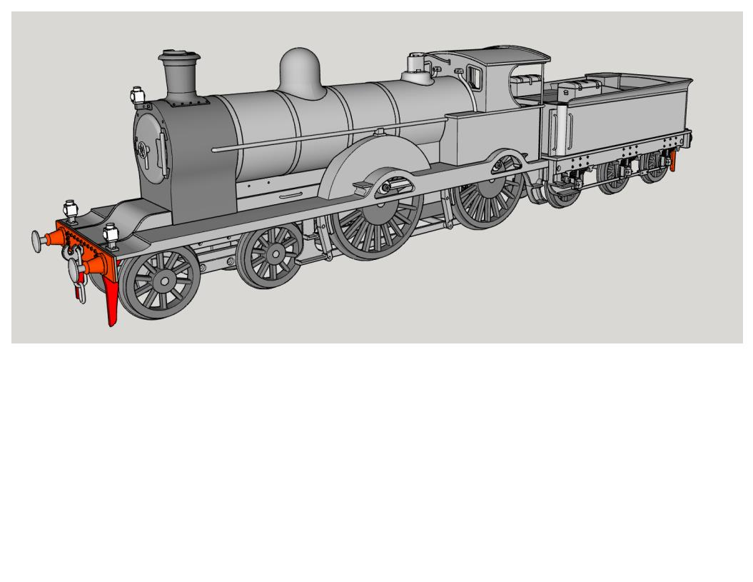

**2 Pilot Truck**

**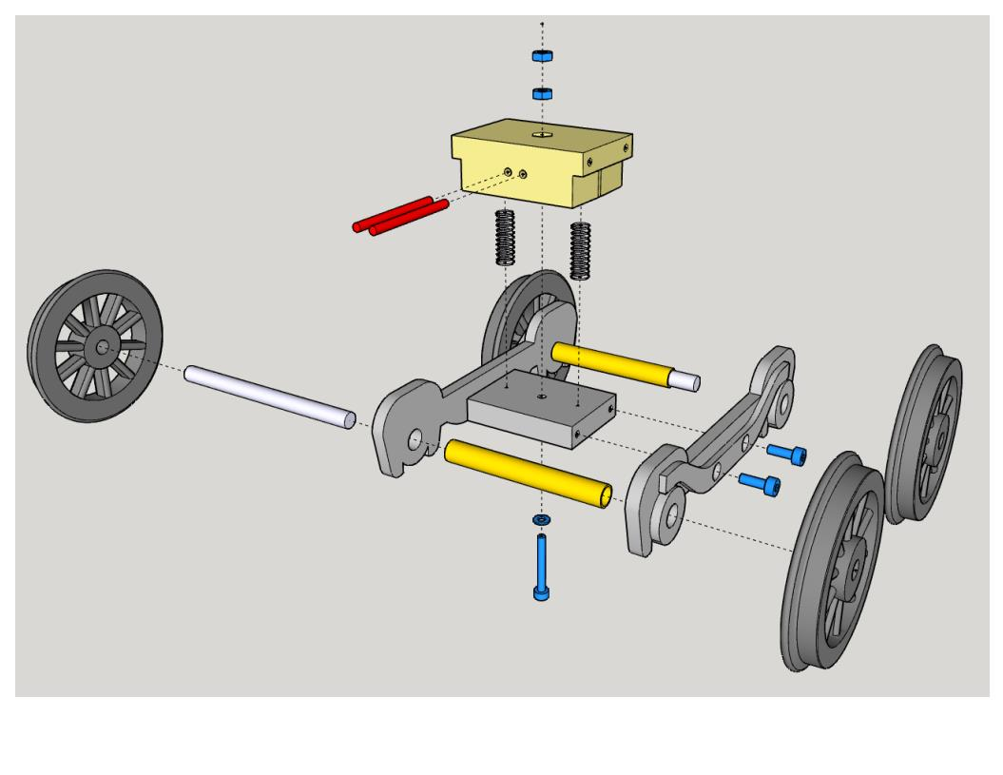**

# 12 Pilot Truck Center. Drill the centr hole 2mm. Drill and M2 tap the 4 side holes.

# 11 Pilot Truck Frames. Assemble with Pilot truck center and the axle bearings. K&S Brass tube 5mm od x .45mm wall x 39mm long. Bearings will be fulsh with outer faces of the side frames.

# 10 Wheels. Are pressed on to the axles. 4mm od x 53mm long ground steel rod. The axle ends to be flush with the outter faces of the wheels.

# 13 Pilot Truck Mount. . Drill the centr hole 2mm. Drill and M2 tap the 4 side holes. 1.8mm drill the two holes on the ftont and rear faces. For 2 lengths of filament to hold one M2 nut in place.

First assemble the truck.

Next the truck mount. Use the 16mm long screw to pull the first nut down to the bottom so the two pieces of filament can be pushed through above the nut. Snip the filament flush both sides. Now, with the springs installed, screw the 16mm screw through the truck center, truck mount and first nut until it is just snug, then back the screw off two turns. With a bit of purple thread lock on its thread, install the second nut, screwing it again until just snug. Then, back the screw off ¼ turn or so, until it is a little loose. Allow time for the thread to set up.

**3 Frame**

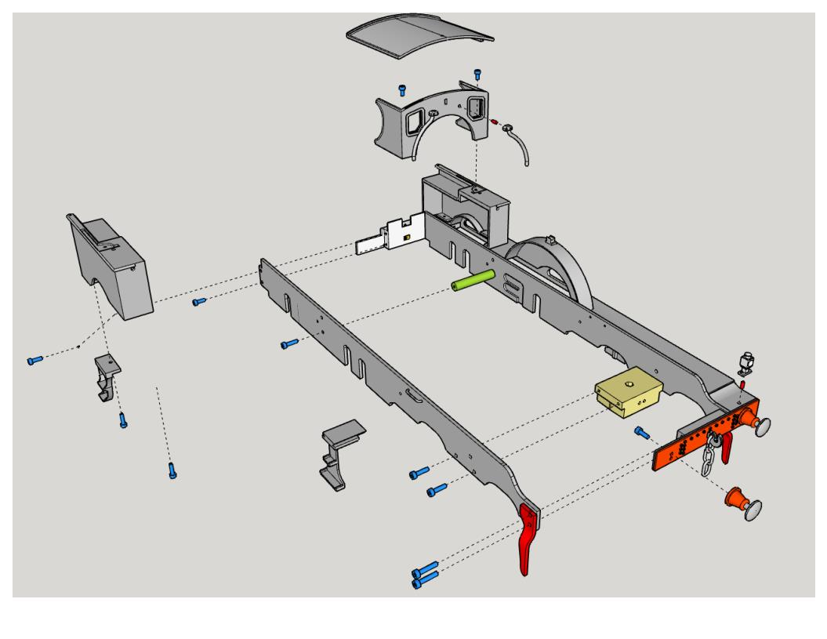

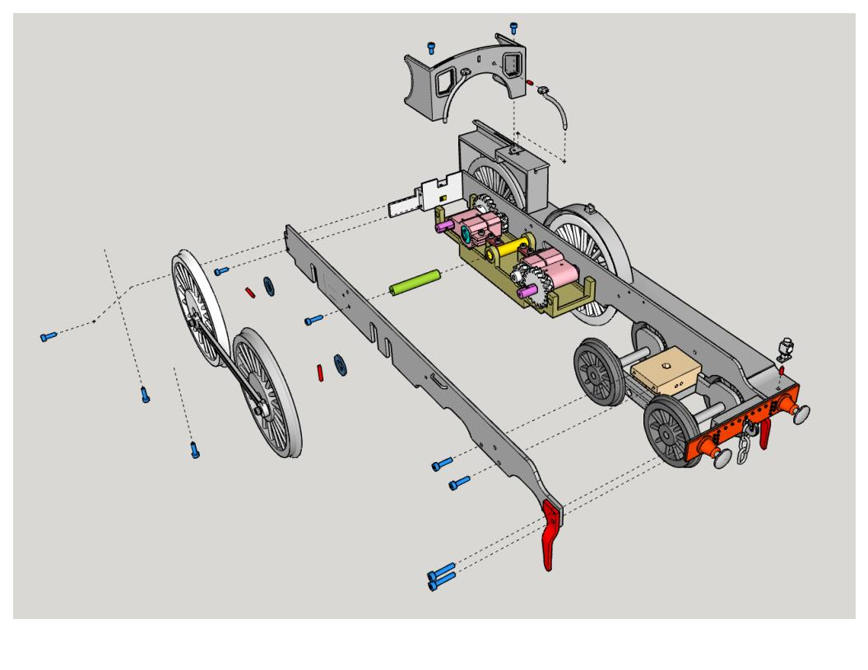# 14 & 15 Frame left & Right. Printed diagonally. Two small holes near top of frame drill 1mm for grab iron. Two medium size holes drill and tap M2 for brake hangers, 9 remaining holes drill 2mm. (See boiler print.)

# 16 Buffer beam. Drill and tap 4 side holes M2

# 17 Buffers. Drill and tap hole M2.

# 18 Guard Irons

# 19 Drag Beam. Drill and tap 4 side holes M2. Also top hole.

# 20 Draw Bar

# 21 & 22 splasher left & right. Small hole at rear drill 1mm, for hand rail. Medium hole at front drill 1.8mm for filament and lamp. 5 large holes 2mm.

# 23 Front steps. Slide into dove tails under front of splasher.

# 24 Rear steps Left. Print mirror for Right.

# 25 Cab & 26 Cab side Left &Right. Drill small hole for hand rail 1mm. large hole top 2mm and the other three drill and tap M2.

# 27 Cab front. Drill 2 holes in bottom 2mm. Two holes in the front 1.8mm for filament pins for the front cab pipes #29.

# 28 Roof. Drill two holes 1mm for hand rails.

# 29 Cab front pipes. Drill for filament pins 1.8mm.

# 30 Hook

#31 3 Link

#32 Lamp. Drill for filament pins 1.8mm.

**4 Boiler/Brakes**

**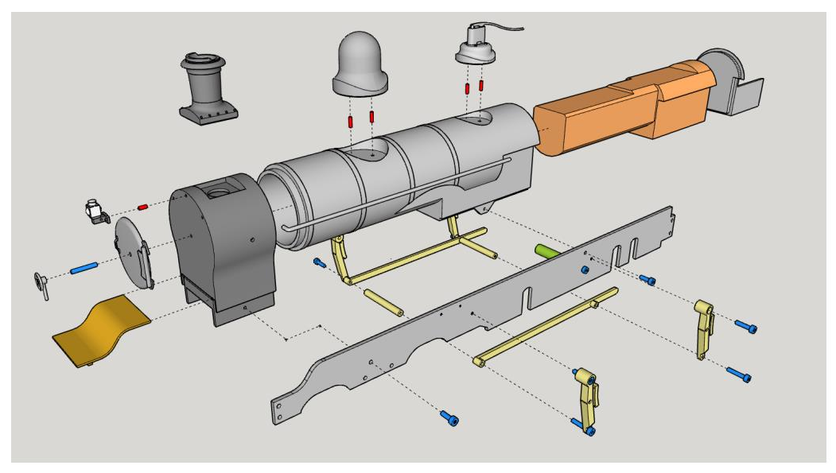**

# 33 Smokbox. Drill front center hole 2mm. Drill top center hole 1.8 for filament pin and smokebox lamp. Drill side holes 2mm for side pipes #38. Drill and tap M2 the low holes for attaching the frame.

# 34 Smokebox Door. Drill center hole 2mm.

# 35 Smokebox door Wheel. Drill and tap M2

# 36 Chimney.

# 37 Boiler. Drill and tap M2 the tabs below firebox for attaching the frame. Drill holes in safety valve and steam dome pockets for filamant pins 1.8mm.

# 38 Side Pipe Left. Print a mirror image one for the right. The underside has a flat for printing aid.

# 39 Front Plate. Push into slot on front of smokebox and snaps into buffer beam.

# 40 Safety Valve. Drill the two holes on the bottom 1.8mm for filament pins.

# 41 Steam Dome. Drill the two holes on the bottom 1.8mm for filament pins.

# 42 Weight. Print 100 % infill. Place into boiler. I added a folded piece of heat shrink tubing at the top to keep it from moving . I printed with .3 layer height. This part adds 240g.

# 43 Back Head.

# 44 Brake. Left side. Also print mirror image for Right side.

# 45 Brake -center connector

# 46 Brake -side connector

# 47 Lamp Smokebox

**5 TENDER-1**

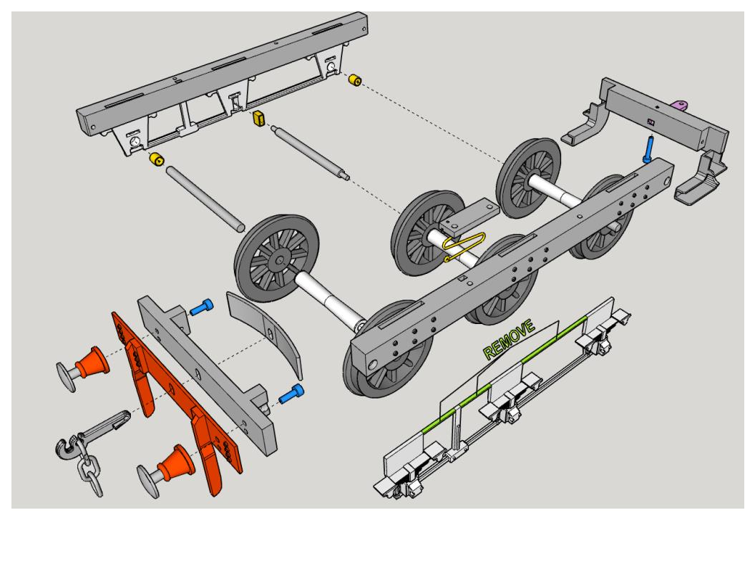

**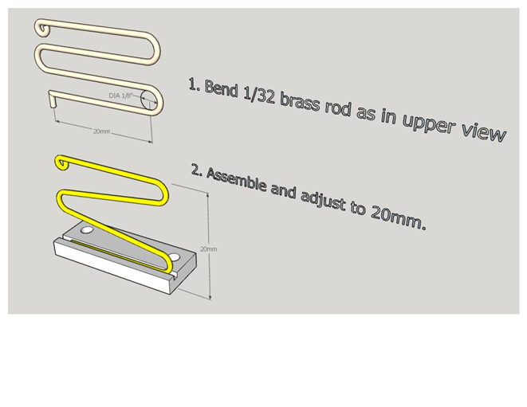**

# 49z Center axle spring Base. Super glue brass rod to base

#50 Wheel, Tender.

Need 3 Axles. 4mm Ground SS Rod each 63mm long. One with both ends turned to 2.3mm for 5mm

# 51 Axle, Sleeve 6.4mm x 40mm x 4.4

# 52 Axle spacer

# 53 Axlebox Set-LEFT. Remove 3 stiffining aid Bits just befor installing into solebar.

# 53 Axlebox Set-Right. Remove 3 stiffining Bits just befor installing into solebar.

Need 4 Bearings, 5mm OD x .45mm Wall X 5mm Long and 2 K&S Rectangular Brass tube .125”x .250”x.014 wall x 5mm long.

# 54 Solebar Left. Drill 4 mounting holes 2mm.

# 54 Solebar-right. Drill 4 mounting holes 2mm.

# 55 Buffer Beam. Drill and tap 2 side holes M2

# 56 Buffer Beam Guard Irons. Drill mounting holes 2mm.

# 57 3 link

# 57 Tender Hook

# 58 Tender Hook Spring

# 59 Drag Beam. Drill and tap 2 side holes M2. Drill and tap top hole M2.

**5 TENDER 2**

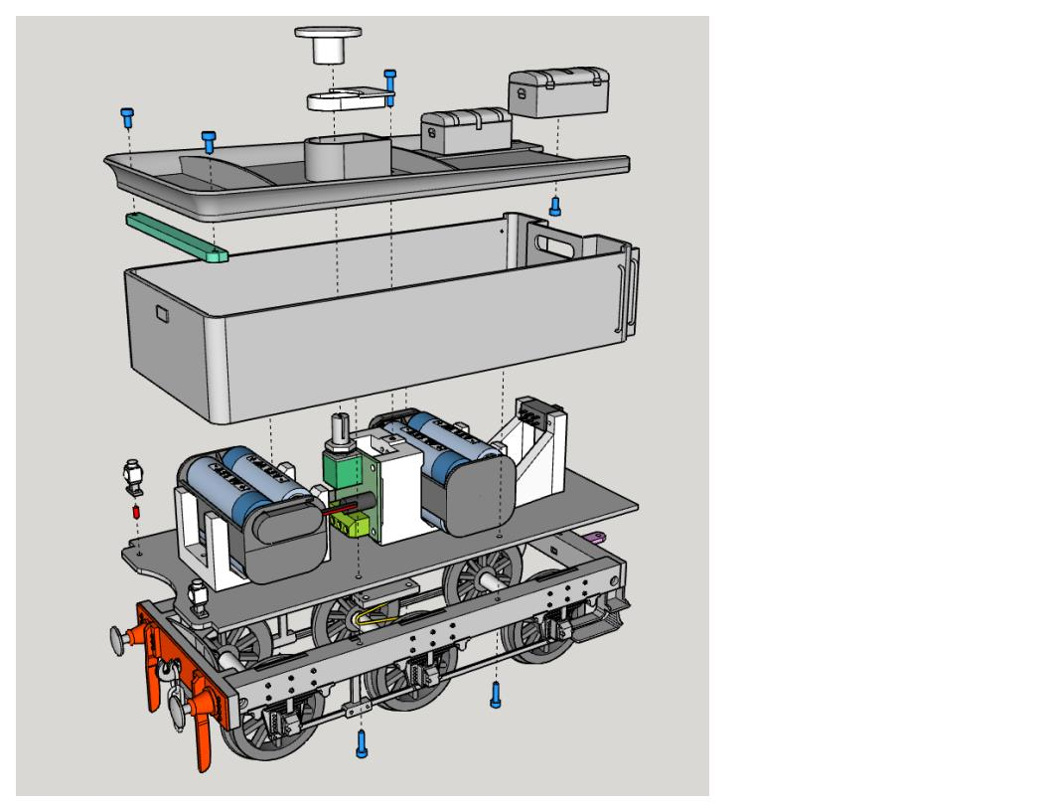

# 60 Tender Deck. 2 holes at the very rear drill 1.8mm for filament pins to mount the lamps. Drill and tap M2 the 2 holes closest the middle for the Z-spring. The other 9 holes drill 2mm.

# 61 Tender Tank. Drill the 4 holes on the bottom 2mm. The 8 holes near the front, drill 1mm for hand rails.

# 62 Tender Top. Drill 5 holes 2mm.

# 63 Tender Top Locator. Drill and tap 2 holes 2M.

# 64 Tank Lid (option 1).

# 65 Tank Lid and Knob (option 2)

# 66 Tender Tool Chest. Drill and tap 1 hole 2mm

# 67 Electrics rack 1. Drill and tap M2. 7 holes front, rear and bottom. The top hole drill 2mm and the 2 filament pin holes 1.8mm. Insert a m2 nut underneasth and then the filament pins.

# 68 Electrics rack 2. Drill and tap the blttlm holes M2.

# 69 Switch extention. Optionaal.

# 70 Lamp. Drill the filament pin hole 1.8mm.

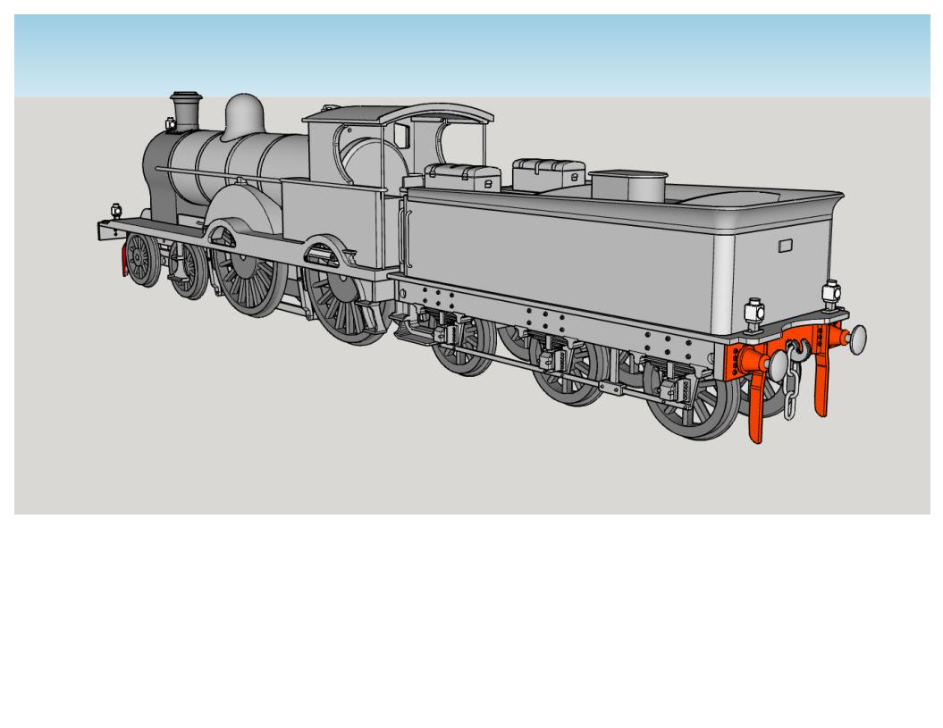

Moo!

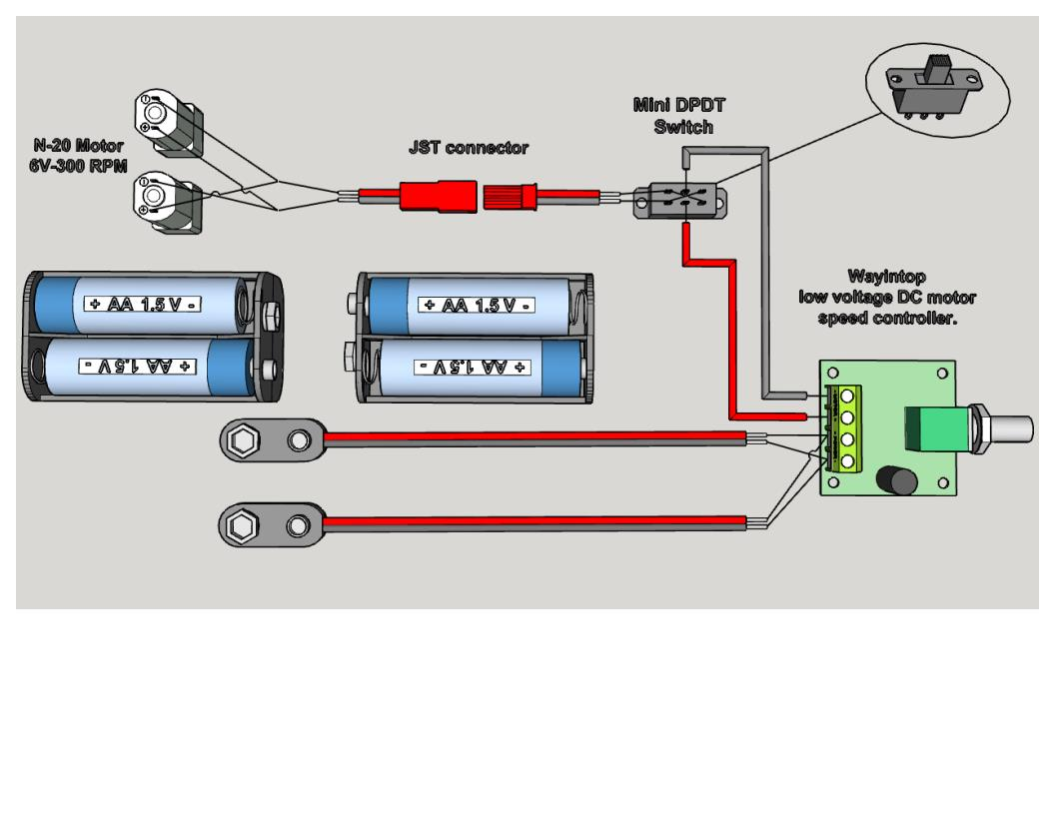

**Purchased parts:**

**M2 Screw, nut and washer assortment**. Amazon Ref;

Kadrick Metric Screw Assortment, 660 Pcs M2 Screws, M2\*4mm/6mm/8mm/10mm/12mm/16mm,12.9 Grade Alloy Steel, Metric Hex Socket Head Cap Screws Nuts Washers Kit, Black Zinc Plated Anti Rust Upgrade

**K&S Brass Tube**: 3, 5, 7mm round brass tube, .125 x .250 Rectangular brass tube

**K&S Brass rod:** 1mm and 1/32 inch

**2 Motors. N20 open gearbox 6V, 300 RPM.** Amazon Ref;

[Alinan 2pcs 6V 300RPM N20 High Torque Speed Reduction Geared Motor with Metal Gearbox Motor for Smart Car DIY RC Toys](https://www.amazon.com/gp/product/B0B1H99H93/ref=ox_sc_act_title_2?smid=A2BWM8QI7O4H7Y&psc=1" \t "_blank)

# **2 Compression springs.** Amazon Ref;

# Uxcell Wire Diameter 0.01", OD 0.16", Free Length 0.59" Spring Steel Coil Extended Compressed Spring 50pcs

**4mm Ground Steel rod.** 2 pcs 53mm long (Pilot truck). 3 pcs 63mm long (Tender). Amazon Ref;

Uxcell 4mm x 300mm 304 Stainless Steel Solid Round Rod for DIY Craft - 5p

**1 Speed controller**. Amazon Ref;

[WayinTop 3pcs PWM Low Voltage Motor Speed Controller DC 1.8V 3V 5V 6V 12V 2A 1803BK 1803B Adjustable Driver Switch with Speed Control Knob (Pack of 3)](https://www.amazon.com/gp/product/B08BJ4WQCV/ref=ox_sc_act_title_4?smid=A22PZZC3JNHS9L&psc=1" \t "_blank)

# **1 Mini switch DPDT.** Amazon Ref;

# Uxcell 10 Pcs High Knob 6 Pin 3 Position DPDT Panel Slide Switch 0.5A 50V DC

**2 Battery holders 2x2 cell AA with snap connectors.** Amazon Ref;

[SDTC Tech 2-Set 4X 1.5V AA Battery Holder and I Type Battery Snap Connector Kit 6 Volt Thicken Plastic Battery Case Box](https://www.amazon.com/sspa/click?ie=UTF8&spc=MTo4MDE1NTI0Mjk2NTY2MTE0OjE3Mzk0NjU3ODQ6c3Bfc2VhcmNoX3RoZW1hdGljOjIwMDAyNTAxMjI3NTA4MTo6MTo6&url=%2FSDTC-Tech-Battery-Connector-Thicken%2Fdp%2FB0858Y4JPL%2Fref%3Dsxin_16_pa_sp_search_thematic_sspa%3Fcontent-id%3Damzn1.sym.c5787da2-212d-48eb-a894-9ea5a87adeb3%253Aamzn1.sym.c5787da2-212d-48eb-a894-9ea5a87adeb3%26cv_ct_cx%3Daa%2Bbattery%2Bholder%26keywords%3Daa%2Bbattery%2Bholder%26pd_rd_i%3DB0858Y4JPL%26pd_rd_r%3Dd195486f-accb-4ba6-91ee-4fa020db7357%26pd_rd_w%3DnPeqx%26pd_rd_wg%3Dl7FrZ%26pf_rd_p%3Dc5787da2-212d-48eb-a894-9ea5a87adeb3%26pf_rd_r%3DF0SVWJGZGH33QQR03KZ3%26qid%3D1739465784%26sbo%3DRZvfv%252F%252FHxDF%252BO5021pAnSA%253D%253D%26sr%3D1-2-6024b2a3-78e4-4fed-8fed-e1613be3bcce-spons%26sp_csd%3Dd2lkZ2V0TmFtZT1zcF9zZWFyY2hfdGhlbWF0aWM%26psc%3D1)

**1 pair JST connectors.** Amazon Ref;

EBOOT 20 AWG JST Plug Connector 2 Pin Male Female Plug Connector Cable Wire for LED Lamp Strip RC Toys Battery, 10 Pairs

**2 Handrail Knobs.** I had on hand. Probably from Walsall.

**1 small tube Permatex Purple Thread Lock.** Amazon Ref;

Permatex 24024 Low Strength Thread locker Purple, 6 ml Tube

**Super Glue**